Study Guide: Civics EOC Exam
John Locke: What ideas is he known for?
- ______________________________________________________________________________
- ______________________________________________________________________________
- ______________________________________________________________________________
What is the social contract?
__________________________________________________________________________________________________________________________________________________________________________
Montesquieu: How did he influence the “Founding Fathers?”
- ______________________________________________________________________________
- ______________________________________________________________________________
What are four concepts found in the Magna Carta that influenced the Founding Fathers?
- ______________________________________________________________________________
- ______________________________________________________________________________
- ______________________________________________________________________________
List three rights that are found in the English Bill of Rights that are found in the US Bill of Rights:
- ______________________________________________________________________________
- ______________________________________________________________________________
- ______________________________________________________________________________
Name three concepts in the Mayflower Compact that influenced the Founding Fathers:
- ______________________________________________________________________________
- ______________________________________________________________________________
- ______________________________________________________________________________
What did Thomas Paine's Common Sense influence the Founding Fathers to do?
_____________________________________________________________________________________
List three things that the British did that made the Colonists angry?
- ______________________________________________________________________________
- ______________________________________________________________________________
- ______________________________________________________________________________
Who was the "Grievances" of the Declaration of Independence addressed to? _____________________
What rights did Thomas Jefferson say every American is entitled to in the Declaration of Independence? _____________________________________________________________________________________
Which Enlightenment philosopher influenced Jefferson in the "Natural Rights" section of the Declaration of Independence? _____________________________________________________________________
List three weaknesses of the Articles of Confederation:
- ______________________________________________________________________________
- ______________________________________________________________________________
- ______________________________________________________________________________
List the goals of the Preamble and describe what they mean:
- ______________________________________________________________________________
______________________________________________________________________________
- ______________________________________________________________________________
______________________________________________________________________________
- ______________________________________________________________________________
______________________________________________________________________________
- ______________________________________________________________________________
______________________________________________________________________________
- ______________________________________________________________________________
______________________________________________________________________________
- ______________________________________________________________________________
______________________________________________________________________________

Define: Separation of Power: ______________________________________________________
____________________________________________________________________________________________________________________________________________________________
Define Checks and Balances: _____________________________________________________________
_____________________________________________________________________________________
_____________________________________________________________________________________
Provide an Example of Checks and Balances for each branch:
- ______________________________________________________________________________
- ______________________________________________________________________________
- ______________________________________________________________________________
Define the Rule of Law: _________________________________________________________________
_____________________________________________________________________________________
What President demonstrated the Rule of Law: ______________________________________________
List two “sources” of American Law:
- ______________________________________________________________________________
- ______________________________________________________________________________
List four “types” of law:
- ______________________________________________________________________________
- ______________________________________________________________________________
- ______________________________________________________________________________
- ______________________________________________________________________________
Which Amendment defined citizenship? ____________________________________________________
List five “qualifications” for becoming a naturalized citizen:
- ______________________________________________________________________________
- ______________________________________________________________________________
- ______________________________________________________________________________
- ______________________________________________________________________________
- ______________________________________________________________________________
What are the two ways to become a natural born citizen? ______________________________________
__________________________________________________________________________________________________________________________________________________________________________
List the six steps to become a naturalized citizen:
- ______________________________________________________________________________
- ______________________________________________________________________________
- ______________________________________________________________________________
- ______________________________________________________________________________
- ______________________________________________________________________________
- ______________________________________________________________________________
List four “obligations” of US citizens:
- ______________________________________________________________________________
- ______________________________________________________________________________
- ______________________________________________________________________________
- ______________________________________________________________________________
List four “responsibilities” of citizenship:
- ______________________________________________________________________________
- ______________________________________________________________________________
- ______________________________________________________________________________
- ______________________________________________________________________________
List the 10 Amendments in the Bill of Rights:
- ______________________________________________________________________________
- ______________________________________________________________________________
- ______________________________________________________________________________
- ______________________________________________________________________________
- ______________________________________________________________________________
- ______________________________________________________________________________
- ______________________________________________________________________________
- ______________________________________________________________________________
- ______________________________________________________________________________
- ______________________________________________________________________________
Define the following Amendments:
13th: __________________________________________________________________________ ______
14th: _________________________________________________________________________________
_____________________________________________________________________________________
15th: _________________________________________________________________________________
19th: _________________________________________________________________________________
24th: _________________________________________________________________________________
26th: _________________________________________________________________________________
List the outcomes of the following Landmark Supreme Court Cases:
Marbury v. Madison ____________________________________________________________________
_____________________________________________________________________________________
Plessy v. Ferguson: ____________________________________________________________________
_____________________________________________________________________________________
Brown v. Board of Education: _____________________________________________________________
_____________________________________________________________________________________
Gideon v. Wainright: ____________________________________________________________________
_____________________________________________________________________________________
Miranda v. Arizona: ____________________________________________________________________
_____________________________________________________________________________________
In re’ Gault: ___________________________________________________________________________
_____________________________________________________________________________________
Tinker v. Des Moines: ___________________________________________________________________
_____________________________________________________________________________________
Hazelwood v. Kuhlmeier: ________________________________________________________________
_____________________________________________________________________________________
US v. Nixon: ____________________________________________________________________
_____________________________________________________________________________________
Bush v. Gore: ____________________________________________________________________
_____________________________________________________________________________________
Describe the following Political Parties:
Democrats:
- ______________________________________________________________________________
- ______________________________________________________________________________
- ______________________________________________________________________________
Republicans:
- ______________________________________________________________________________
- ______________________________________________________________________________
- ______________________________________________________________________________
Libertarians: __________________________________________________________________________
Socialist: _____________________________________________________________________________
_____________________________________________________________________________________
Communists: __________________________________________________________________________
_____________________________________________________________________________________
List the Constitutional Qualifications for the following offices:
President:
- ______________________________________________________________________________
- ______________________________________________________________________________
- ______________________________________________________________________________
House of Representatives:
- ______________________________________________________________________________
- ______________________________________________________________________________
- ______________________________________________________________________________
Senate:
- ______________________________________________________________________________
- ______________________________________________________________________________
- ______________________________________________________________________________
Define the following:
Party Platform: ________________________________________________________________________
Political Action Committee: ______________________________________________________________
_____________________________________________________________________________________
Bias: _________________________________________________________________________________
Media Watching Role: __________________________________________________________________
Propaganda: __________________________________________________________________________
Public Policy: __________________________________________________________________________
List 3 things each level of government is responsible for:
- ______________________________________________________________________________
- ______________________________________________________________________________
- ______________________________________________________________________________
What is a “domestic policy”? _____________________________________________________________
_____________________________________________________________________________________
What is a “foreign policy”? _______________________________________________________________
_____________________________________________________________________________________
List the ways the President deals with foreign policy:
- ______________________________________________________________________________
- ______________________________________________________________________________
- ______________________________________________________________________________
- ______________________________________________________________________________
- ______________________________________________________________________________
List the ways Congress deals with foreign policy:
- ______________________________________________________________________________
- ______________________________________________________________________________
- ______________________________________________________________________________
- ______________________________________________________________________________
Define the following international organizations:
United Nations: ________________________________________________________________________
_____________________________________________________________________________________
NATO: _______________________________________________________________________________
_____________________________________________________________________________________
NAFTA: ______________________________________________________________________________
_____________________________________________________________________________________
UNICEF: ______________________________________________________________________________
_____________________________________________________________________________________
International Court of Justice (World Court): _________________________________________________
_____________________________________________________________________________________
WTO ________________________________________________________________________________
_____________________________________________________________________________________
Red Cross: ____________________________________________________________________________
_____________________________________________________________________________________
NGOs: _______________________________________________________________________________
_____________________________________________________________________________________
What two wars fought in Europe and Asia where the last “declared wars”?________________________
_____________________________________________________________________________________
Name two “undeclared” wars? ___________________________________________________________
_____________________________________________________________________________________
What was the decades long conflict between the United States and the Soviet Union referred to?
_____________________________________________________________________________________
What were the two conflicts with Cuba in the 1960s? _________________________________________
_____________________________________________________________________________________
What country were the two “Gulf Wars” fought against? _______________________________________
Define the following “forms” of government:
Direct Democracy: _____________________________________________________________________
_____________________________________________________________________________________
Representative Democracy: ______________________________________________________________
_____________________________________________________________________________________
Absolute Monarchy: ____________________________________________________________________
_____________________________________________________________________________________
Constitutional Monarchy: ________________________________________________________________
_____________________________________________________________________________________
Communism: __________________________________________________________________________
_____________________________________________________________________________________
Socialism: ____________________________________________________________________________
_____________________________________________________________________________________
Autocracy: ____________________________________________________________________________
Oligarchy: ____________________________________________________________________________
What “system” of government is power shared between the national and regional governments? _____________________________________________________________________________________
What system of government do the regional governments tell the central government what to do?
_____________________________________________________________________________________
What system of government does the central government have all of the power?
_____________________________________________________________________________________
Who is the executive chosen by in a Parliamentary System? ____________________________________
What are powers held by the national government called?_____________________________________
List ten constitutional powers of the national government: _____________________________________
_____________________________________________________________________________________
_____________________________________________________________________________________
List the three levels of Federal Courts: ______________________________________________________
_____________________________________________________________________________________
List the three levels of the Florida Court System: _____________________________________________
_____________________________________________________________________________________
What are powers shared by the national and state governments called? __________________________
List three powers shared by the national & state governments: _________________________________
_____________________________________________________________________________________
What are powers held by state governments called: __________________________________________
List three powers held only by state governments: ____________________________________________
_____________________________________________________________________________________
What do you call the system in which powers are shared by national and state governments?
_____________________________________________________________________________________
How are federal amendments made? ______________________________________________________
_____________________________________________________________________________________
List the Steps through Congress for passing a law:
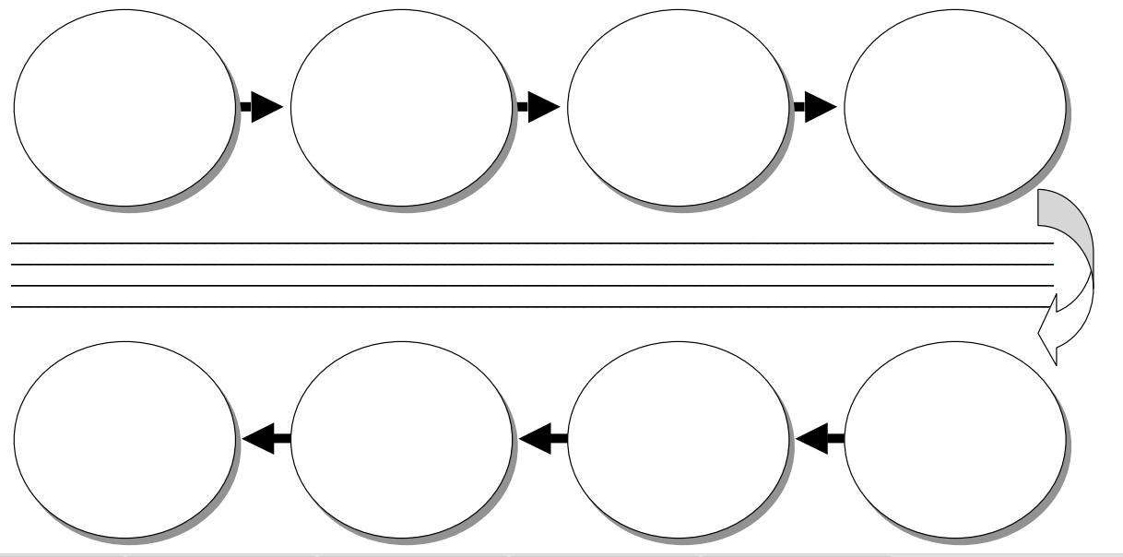

Complete the Chart Comparing the US & Florida Constitutions:
United States Florida
Articles: | Articles:
Size: | Size:
Rights Contained in: | Rights Contained in:
 | Specifics:
List three ways to amend the Florida Constitution
- ______________________________________________________________________________
- ______________________________________________________________________________
- ______________________________________________________________________________

List Services:
National: ___________________________________________________________________________
___________________________________________________________________________________
State:______________________________________________________________________________
___________________________________________________________________________________
Local: ______________________________________________________________________________
___________________________________________________________________________________

